How to Use Microsoft Azure CI/CD and GitHub to Put A React Application Online

Prerequisites:
- Already have an established GitHub and Microsoft Azure account
- A device that can run VSCode or another similar IDE as well as work with larger file sizes and types
- A WiFi connection or wireless hotspot of some sort to connect to the internet
- Have a completed React application from Level 0 to work with in this tutorial and access to that code both locally and through GitHub
- Access to the Architecture Resources site: https://www.lewisunivcs.com
- Access to this link in GitHub for the sample implementation at this level: https://lively-dune-0d54d9d10.3.azurestaticapps.net/

Part 1: Get Previous Code, GitHub Repository, and Azure Ready
- Make sure you have all of the steps completed for the tutorial at Level 0 and you have a local React application you’ve tested and pushed to the web repository on GitHub
- Now, go to Azure and if you have an account already set up, you should be able to see a screen similar to this but without all the projects shown:
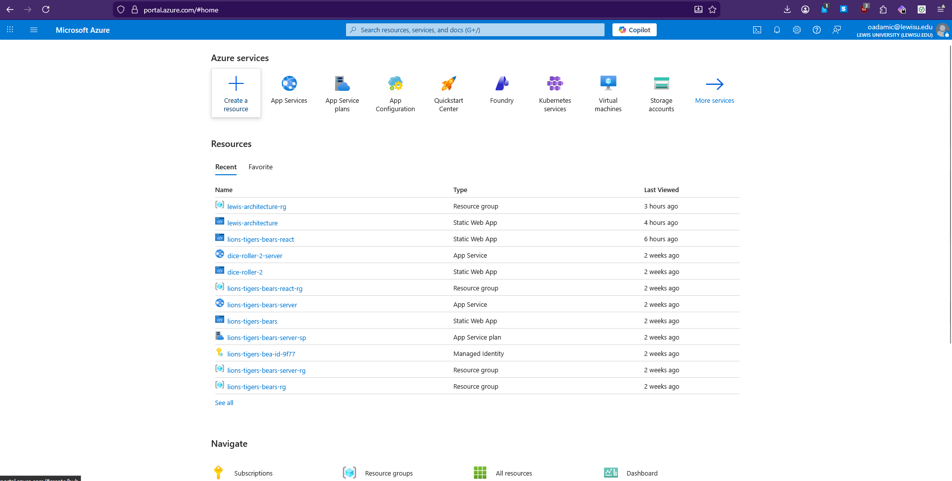
- Then you want to click on Create a resource and search for Static Web App

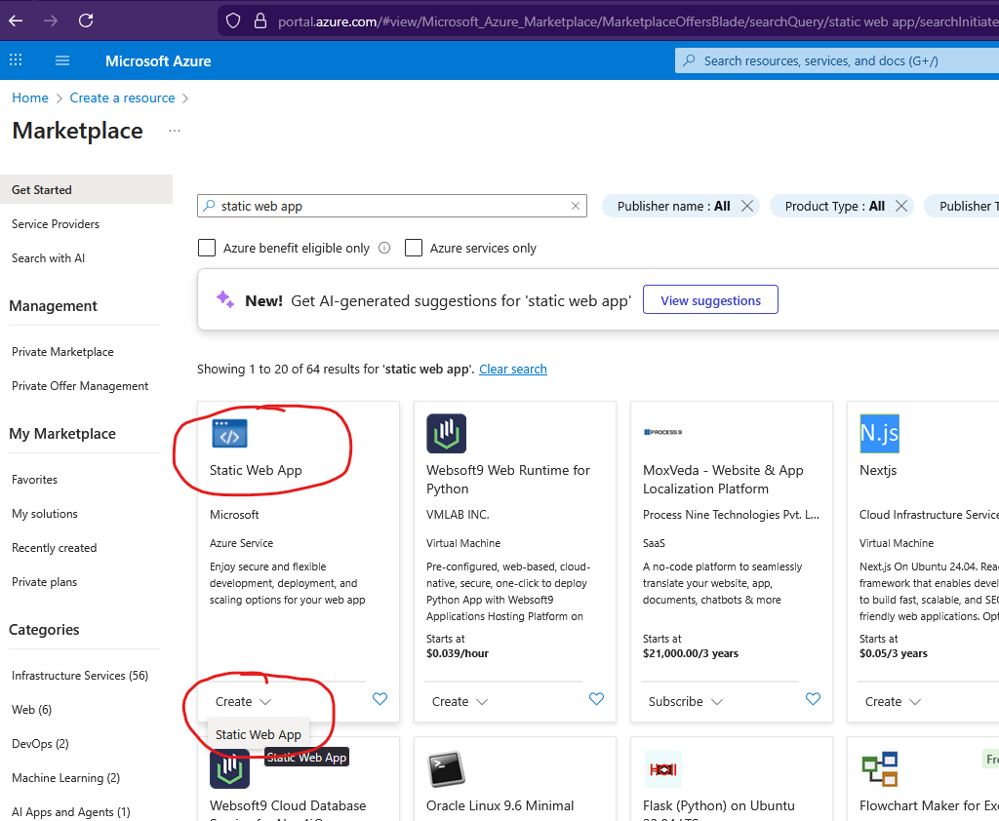

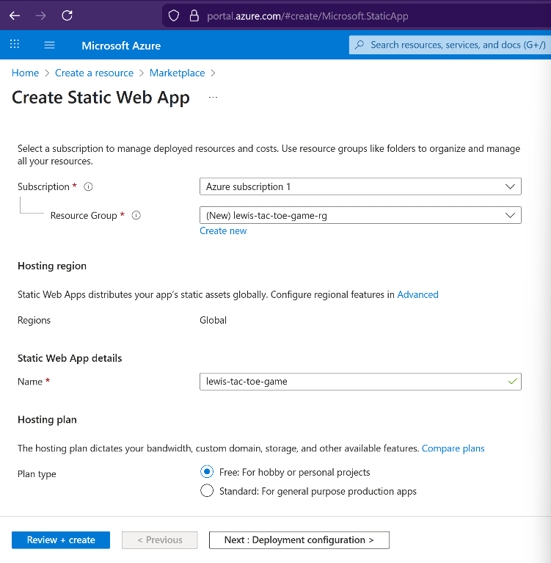
- Now you want to select a free subscription plan and create a new resource group. Try to match the name of the resource group with what you will named the static web app and then add rg to the end so you can tell the two apart like so:

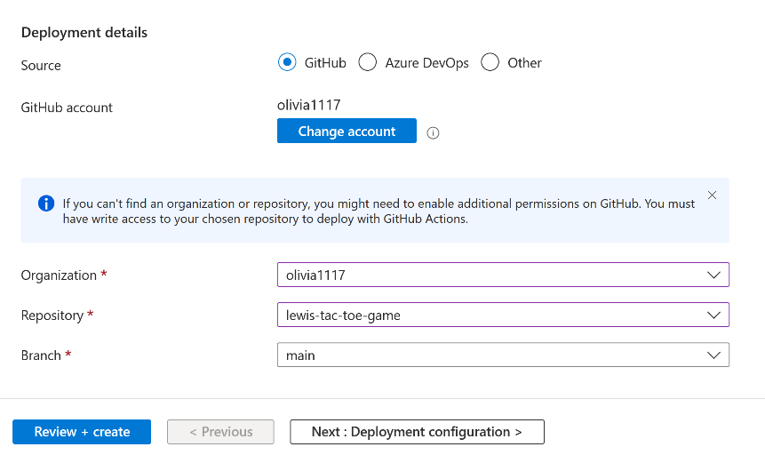

- Then you want to skip over to the next screen and leave the Deployment Configuration settings alone. Then you want to set the Region to whichever location is closest to you. I’m in the Midwest, so Central US works best for me:
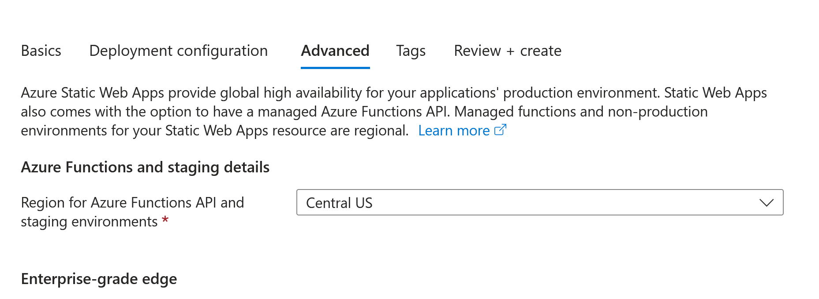

- Skip over the Tags screen and then check over everything you wrote on the Review and Create page before clicking on the blue Create button.
- You’ll soon see Azure working its magic and then it will say your deployment is complete! You’ll then want to click on the Deployment details and click on the link to your resource to view it. You’ll see a screen that looks like this that shows the URL of your website or you can click on the button to visit the site:
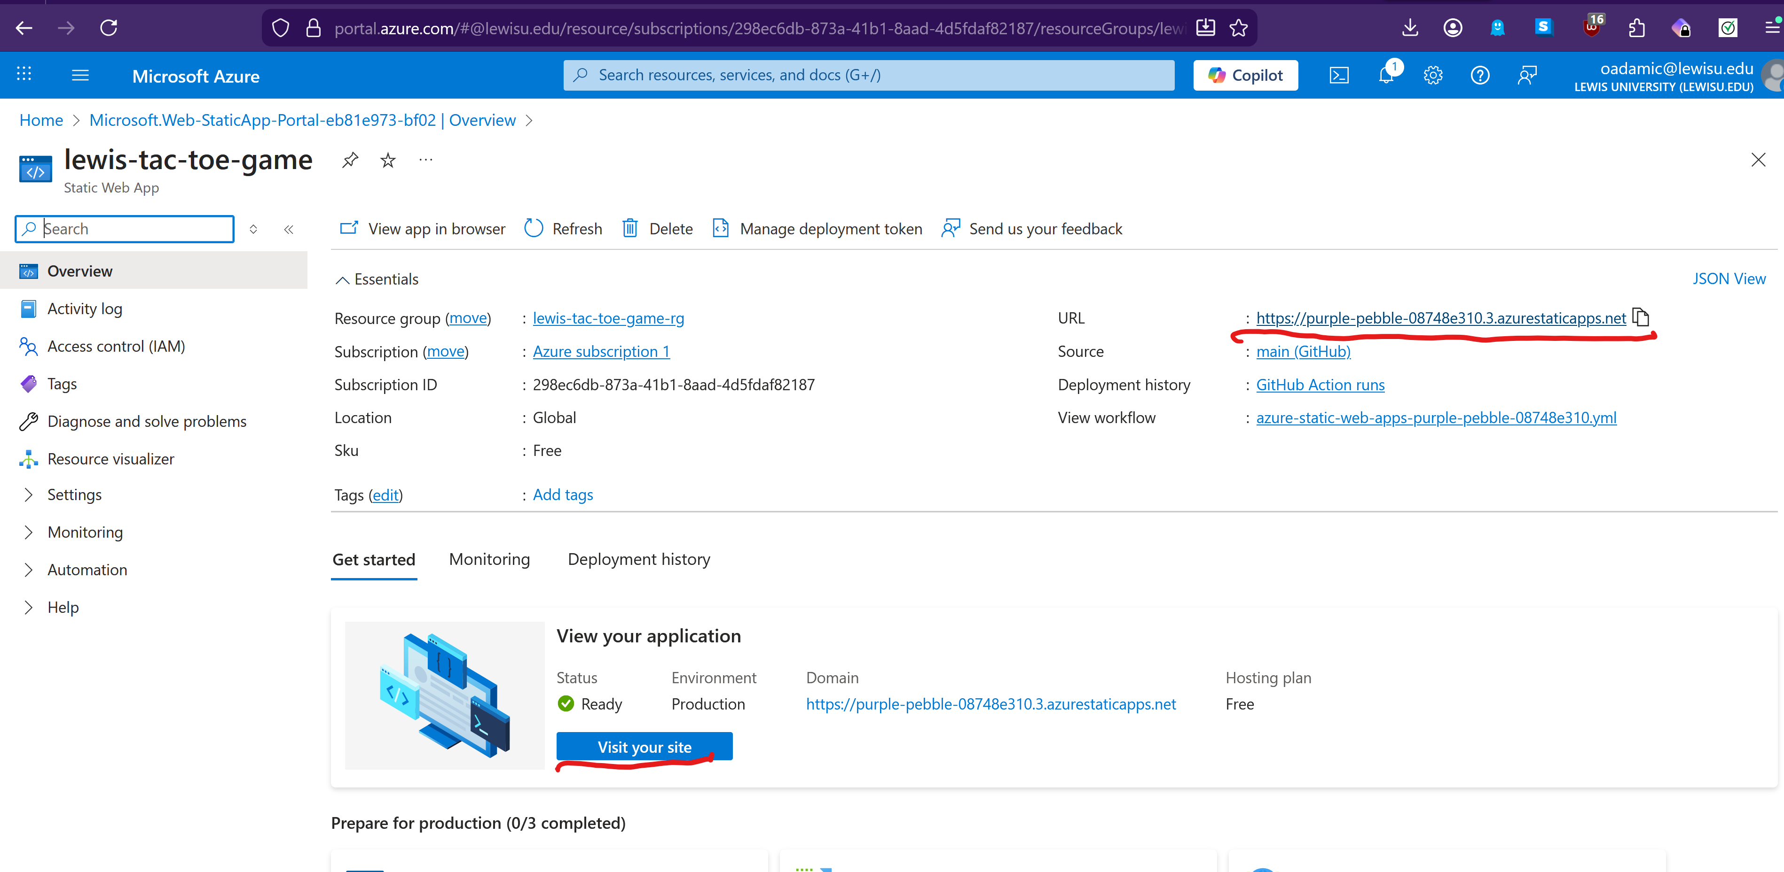

- If you hooked everything up correctly, then you should be able to click on the link and it will take you to your Azure website where you can see what it looks like and it should look like what you built in the previous tutorial:

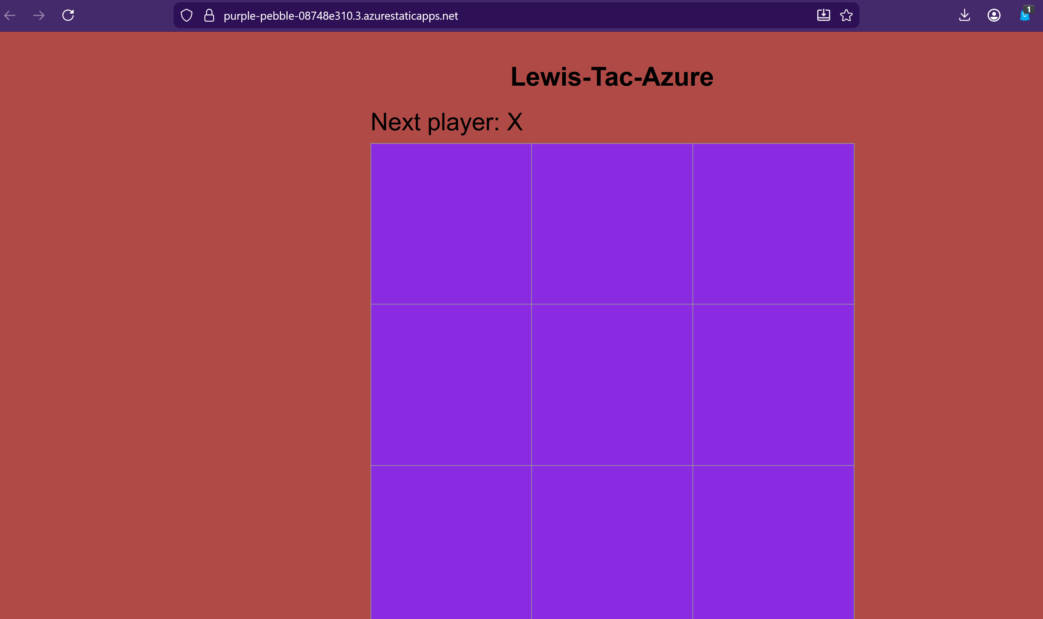
- Now you have an accessible place where you can make changes to your application online and allow people to visit!

Part 2 – Learning more about GitHub Actions and pulling changes down to the local repository
- If you go over to your online GitHub repository and click on the actions tab, you should be able to see the action that ran that corresponds to setting up your website:
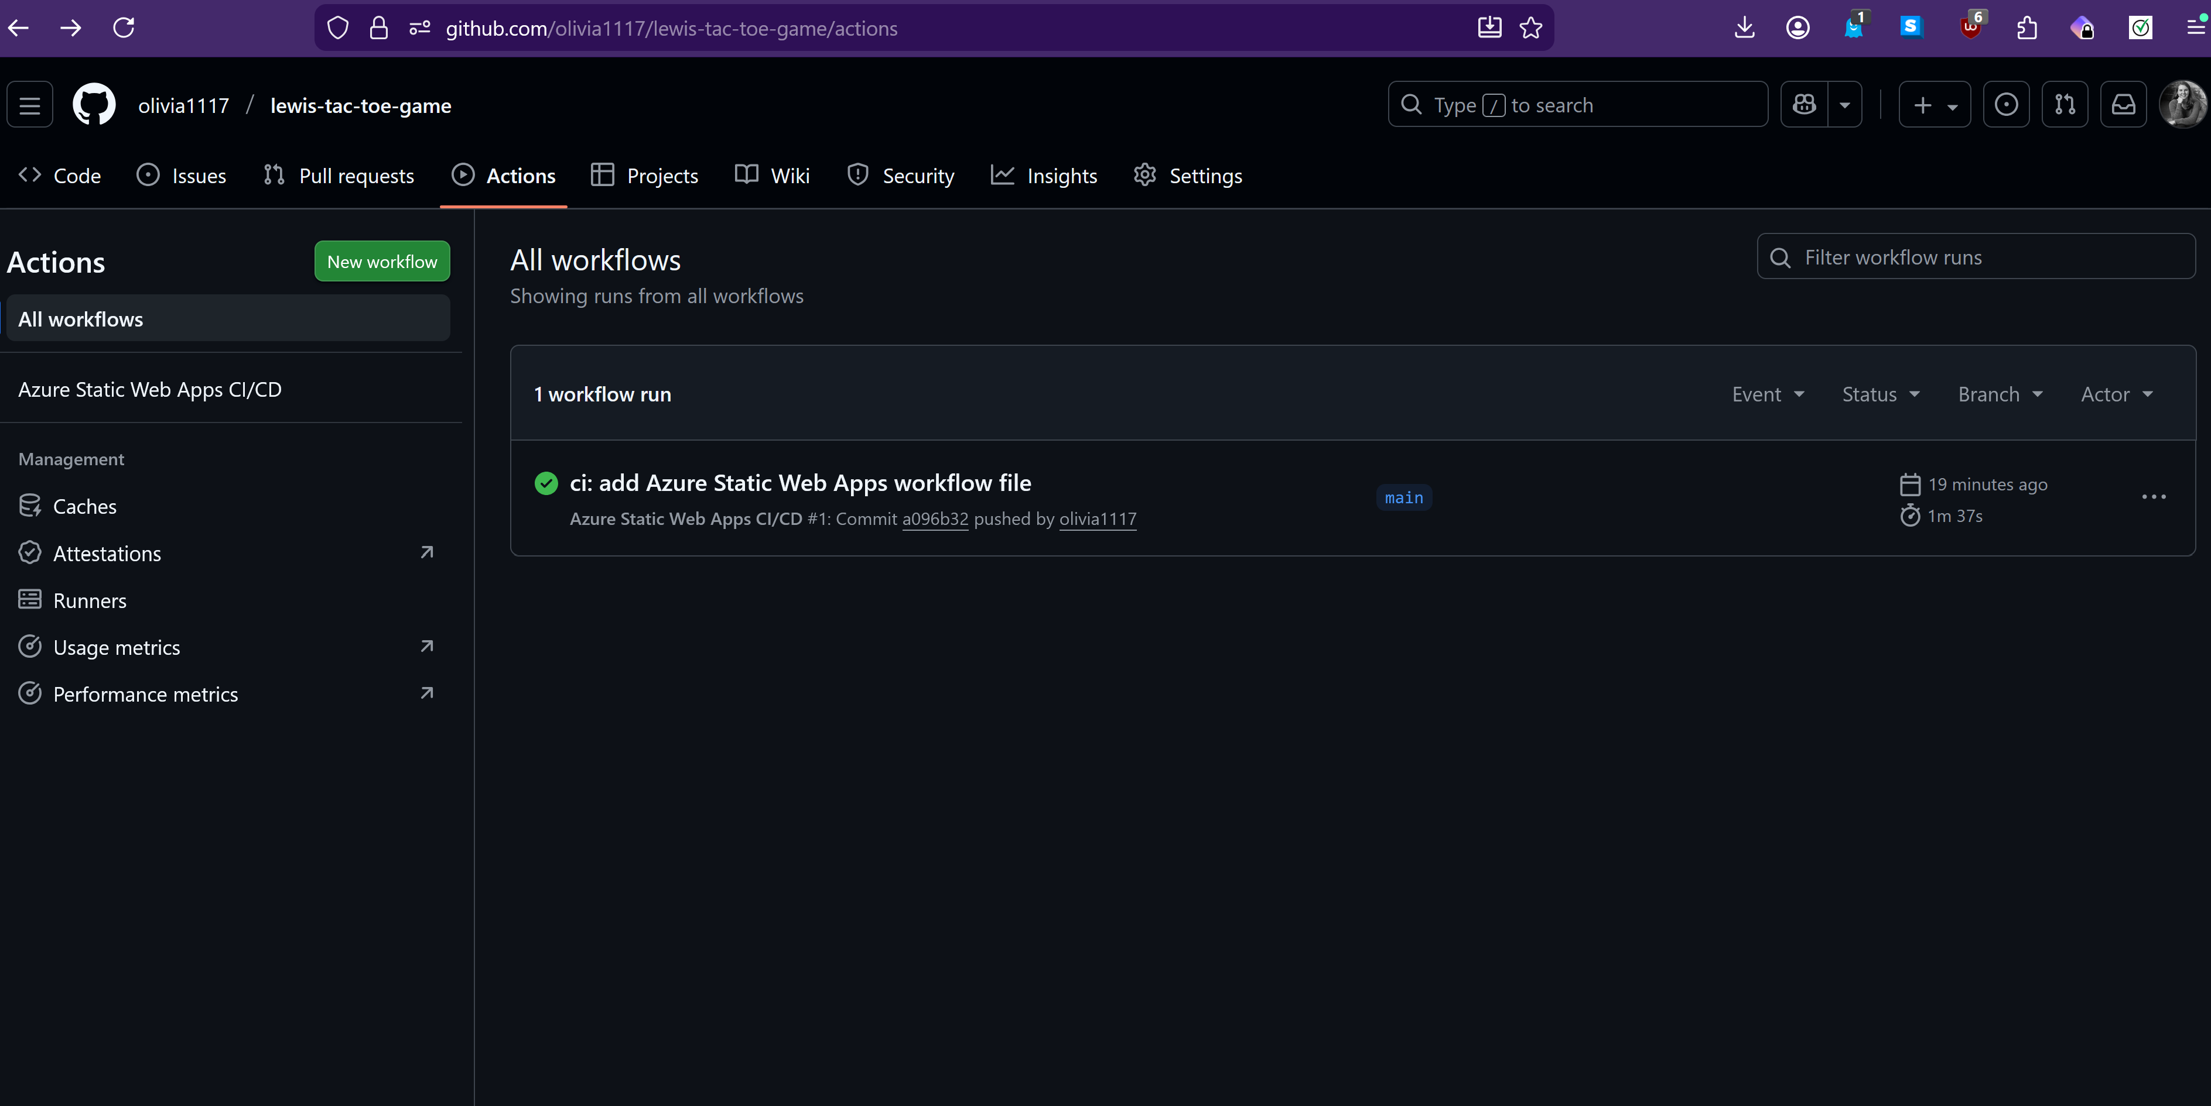
- If you have some extra time, you should now pull these changes you made online to your local repository because it’s behind an update! You need to make sure the online version isn’t an update ahead of what your local repository looks like. So open up your local repository in VSCode or another IDE and then go to the Source Control option:
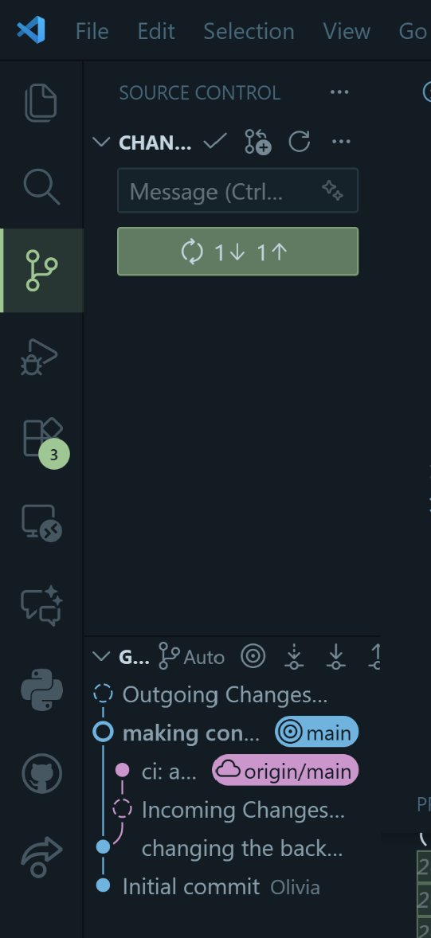
Yours might not look quite the same because I changed my README.md file a little and tried to push my change. It gave me a warning because I tried to push a new change without first pulling the new changes from the online repository hence the two ones in the green button showing that there’s a change I need to pull and one I need to push.

So then if you click on that or in your case, you would select the dropdown like last time and select pull and then your changes from online should appear in your local repository and now you’re up to date!

